
June 2025

Special Local Government Pension Scheme (LGPS) Bulletin

LGPS England & Wales ‘Access and Fairness’ Consultation Launched
On 15 May 2025, the Ministry of Housing, Communities and Local Government (MHCLG) launched a consultation on changes to the Local Government Pension Scheme (LGPS) in England and Wales.
The proposed changes are intended to improve fairness in and access to the LGPS. The proposals include:
Survivor benefits and death grants
- Equalising survivor benefits
- Removing the age 75 limit for death grant eligibility
- Removing the requirement for a death grant to be paid to the personal representatives where it is not paid within the two-year period
- Removing the requirement to nominate a cohabiting partner in the 2008 Scheme.
Gender pensions gap benefits
- Making authorised absences of less than 31 days automatically pensionable
- Aligning the cost of buying back lost pension for authorised absences of over 30 days with the standard member contribution rates
- Extending the time limit for electing to buy back lost pension from 30 days to 12 months
- Removing the limit that provides employers must only share the cost of buying back lost pension for a maximum period of three years
- Updating the definition of child-related leave to include all periods of additional maternity, adoption and shared parental leave without pay.
Gender pensions gap reporting
- Making gender pensions gap reporting mandatory for administering authorities with effect from the 2025 valuation
- The actuarial report and the annual report of that year must include the required information
- Employers with more than 100 employees will also be required to report gender pensions gap (reported in the rates and adjustments certificate)
Opt Outs
- Making reporting the rate of opt outs mandatory for administering authorities
- Reports must be included in the annual report each year
- Collection of additional opt-out data by MHCLG e.g. ethnicity, religion, marital status, hours, salary etc
- There will be a mandated opt out form
Forfeiture
- Removing the requirement that a member must have left employment because of the offence for forfeiture to be possible
- Abolishing the three-month time limit for an application to be made
- Removing regulation 92 (interim payments directions)
- Publishing guidance on making a forfeiture application.
McCloud remedy
Correcting regulations to provide the McCloud remedy works as expected in relation to:
- Recalculating pension debits
- Deaths on 30 September 2023
- Transfers from other public service pension schemes where the member is over age 65
- Interest on Club transfers
- Interest on part 4 tax losses.
Abolition of Life Time Allowance changes
- Revoking regulation 50 (limit on total amount of benefits) and withdrawing LTA actuarial guidance
- Amending the definition of a Benefit Crystallisation Event (BCE) i.e. the occasions, which each trigger a test against the lifetime allowance
- Updating actuarial guidance on cash commutation to include the payment of Pension Commencement Excess Lumps Sums (PCELS) i.e. a taxable lump sum that may be paid to an individual when they start taking their benefits from the scheme. An individual may take a PCELS where they have exhausted their lump sum and death benefit allowance in certain conditions.
- Legislating for the maximum PCELS to be 25% of the capital value of the benefits being crystallised (subject to contracting out limits).
Other changes
- Allowing small pot payments to be made to members who left the LGPS before 1 April 2008
- Allowing deferred members who left before 1 April 2008 to buy additional pension with in-house AVC pots.
- Allowing for the payment of refunds beyond the 5-year limit
- Other miscellaneous changes.
Most of these proposed changes are issues that we have been campaigning on for some time and I broadly welcome them. The full consultation can be found here and closes on 7 August 2025. I would welcome any comments that members may have on the proposals by no later than Wednesday 16th July.

LGPS Annual Report
The Scheme Advisory Board has published its 12th Scheme Annual Report which aggregates information supplied by the 86 Administrative Authorities of the fund as of 31 March 2024. It provides a single source of information regarding the LGPS.
In Summary
- The LGPS is one of the largest defined benefit (DB) schemes in the world and is the largest DB scheme in England and Wales, with 15,049 active employers, 6.7m members (an increase of 2.8%) and assets of £390bn (an increase of 10.1%) on 2023/24.
- There are 2.15m active members (paying into the scheme), 2.4m deferred and 2.14m pensioners
- As of 31st March 2022, the LGPS had an estimated overall funding level of 107%.
- Total assets increased to £390bn, an increase of 10.1 per cent from £354bn
- The return on investment over 2023-2024 was 8.9 per cent comparing very favourably to UK CPI year on year inflation of 2.5 per cent (Sept – Sept)
- Total investment management costs increased by £49.6m (2.9 per cent). Management fees increased by £52m, transaction costs increased by £20m while performance fees decreased by £15m and other [investment] costs decreased by £6m
- Total administration and governance costs increased by 5.7 per cent (£15.7 million) to £290.8 million in 2023-2024 from £275.1 million in 2022-2023. This was primarily due to an increase of £19m in administration costs.
LGPS Financial Performance

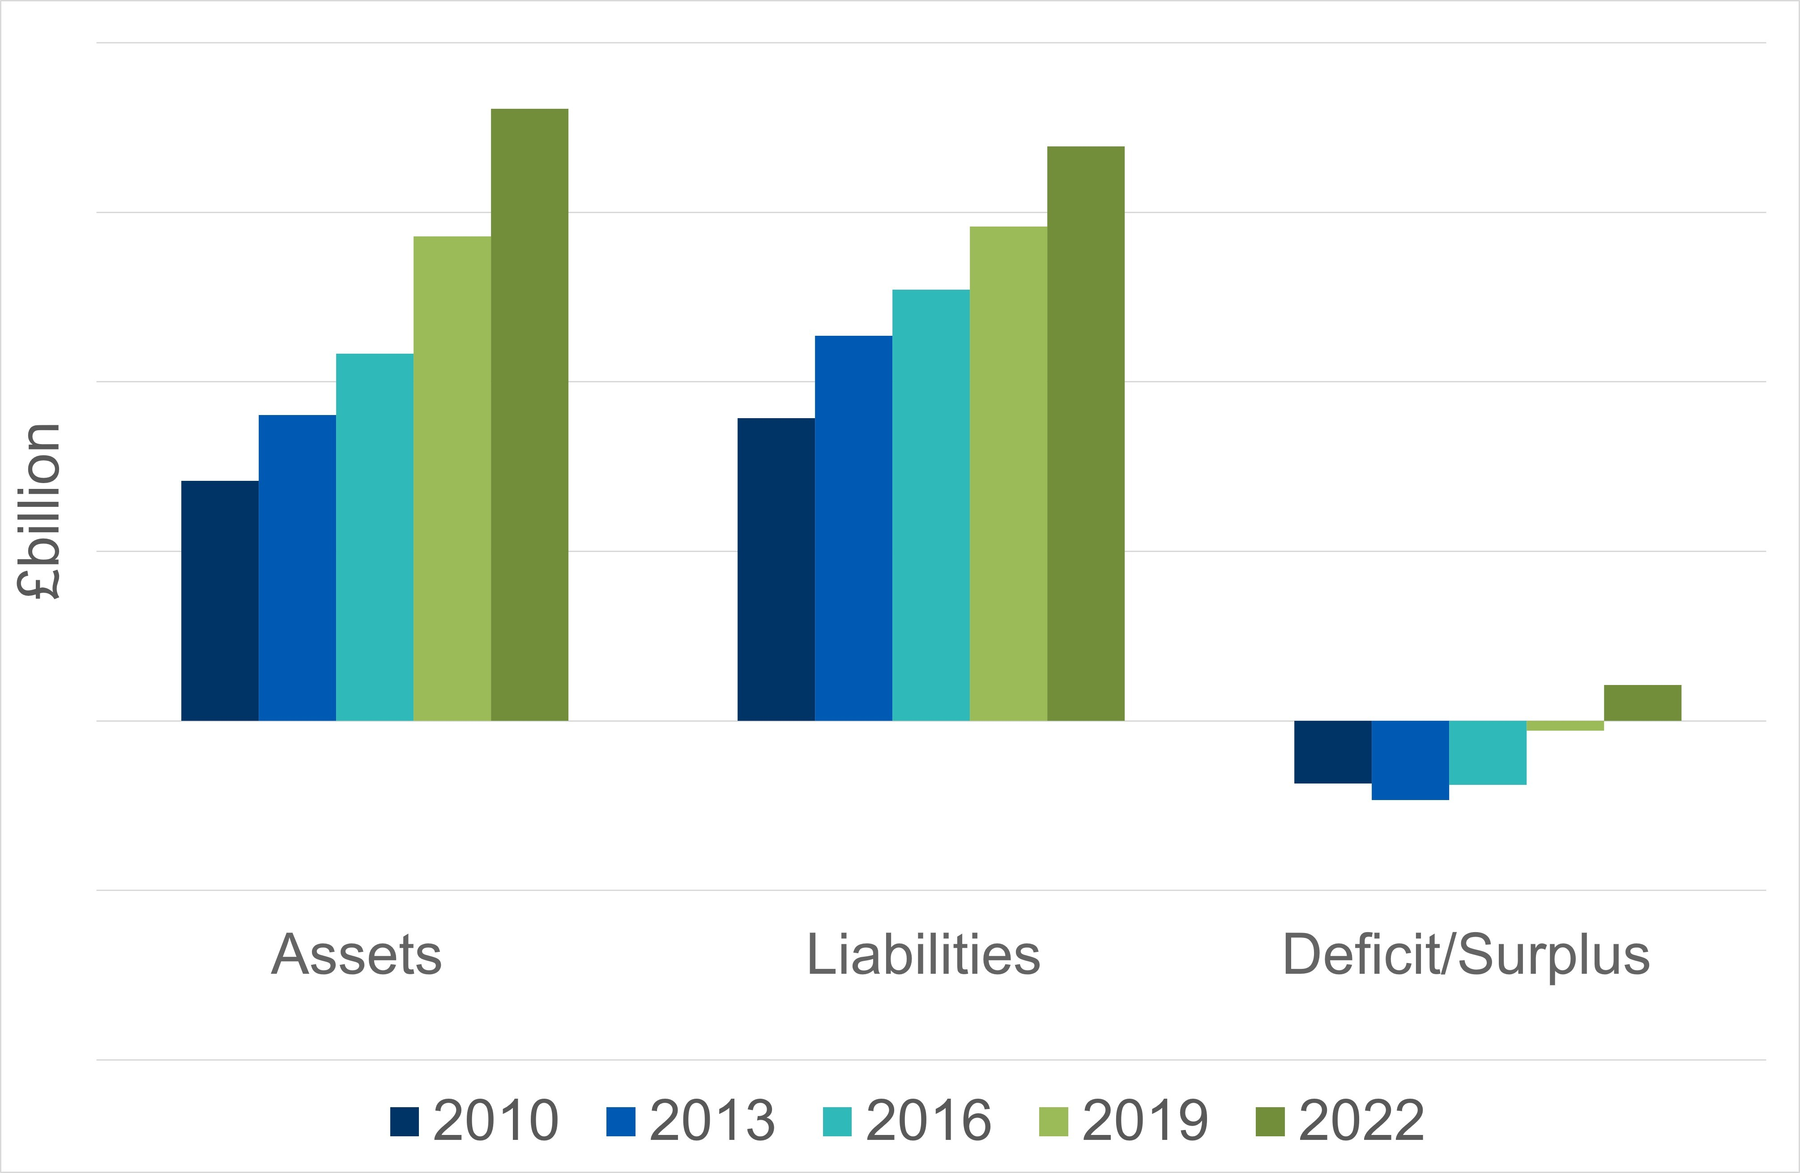

Government’s Response to LGPS ‘Fit for the Future’ Consultation
Members may recall that our response to the above outlined our scepticism and opposition to the government’s proposals to increase and mandate pooling in the LGPS and reduce the number of pools to six. On 29 May 2025 the Government published its response setting out that its proposed reforms will go ahead and be legislated for in the forthcoming Pensions Schemes Bill. The consultation also outlined some governance reforms for Administering Authorities including:
- Appointing a senior LGPS officer with overall delegated responsibility for the management and administration of the Scheme
- A requirement to prepare strategies on governance, knowledge and training (replacing the governance compliance statement), and administration
- The knowledge and training strategy will be required to include a conflict of interest policy
- The requirement to take part in an independent governance review (IGR) every three years
- Ensuring pension committee members meet new knowledge and understanding standards
- Appointing an independent adviser (non-voting) to the pension committee.
Whilst the Government’s response provides clarity and commits to implementing the Good Governance recommendations we first asked for in 2021, the scale and pace of the proposed changes carries significant risk and the implementation timetable places considerable pressure on funds who are already dealing with election-related turnover, local government reorganisation (LGR), staffing constraints, the 2025 valuation, the implementation of the McCloud remedy and preparations for the Pensions Dashboard.
Gender Pensions Gap Roundtable Event
The LGPS has organised an event to bring together leading industry figures and representatives from across public sector pensions to inform our response to the Governments Access and Fairness consultation. I shall be attending the event on behalf of the GMB on 18 June 2025 at the Local Government Association offices in Smith Square, Westminster.
The Pensions Ombudsman (TPO) recently did not uphold a complaint concerning a council’s decision to award a lump sum death benefit to a nominated beneficiary instead of the late member’s spouse.
The Ombudsman:
- Recognised that regulation 46 gives the administering authority absolute discretion to decide how the member’s lump sum death benefit should be distributed
- Agreed with the council’s decision not to further investigate any allegations made by the member’s spouse as it was a matter for the police.
All the more reason to ensure members have completed their expression of wish forms.

Scotland
The Scottish Local Government Pension Scheme Advisory Board are proposing the following amendments:
Neonatal Care Leave and Pay (Consequential Amendments to Subordinate Legislation) Regulations 2025.
Please share this bulletin. Any member who wishes to receive it directly should email george.georgiou@gmb.org.uk and ask to be added to the distribution list. Likewise, if you wish to be removed.
This change entitles employed parents the right to paid leave where their child is admitted to neonatal care starting within 28 days of birth and goes on to spend seven or more continuous days in care. This new entitlement applies to children born on or after 6th April 2025.
Increasing the Normal Minimum Pension Age’ (NMPA) from age 55 to age 57 from 6 April 2028 to align with the Finance Act 2022. There are some protections in place for transition members, which will allow some individuals to retain the right to take their benefits at age 55. The protected pension age in the LGPS, which is the right to take benefits before NMPA, needs to be considered.

